Vyskan
Product Name | 4G LTE Magnetic SOS Nano Tracker
Product Model | VN04
Magnetic. Covert. Vigilant.
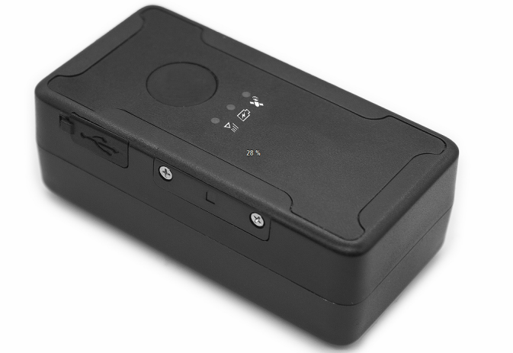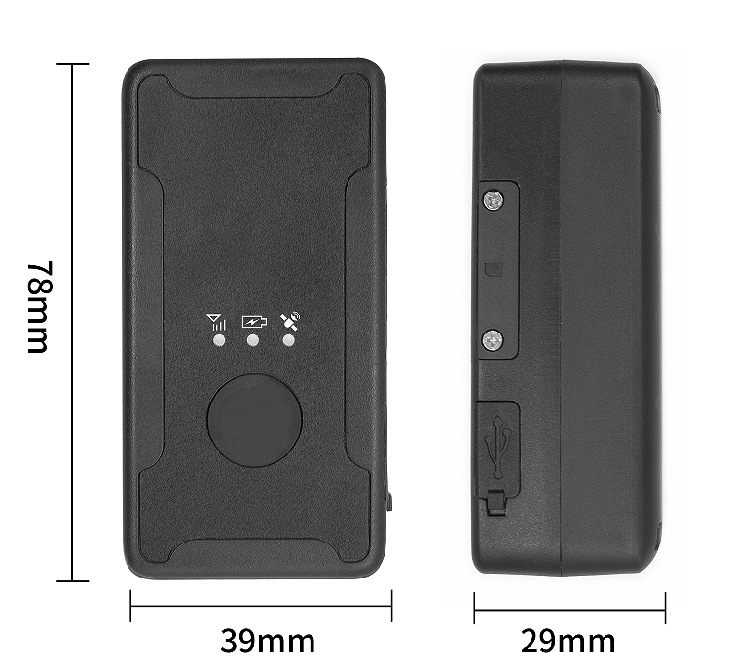
Engineered for rapid deployment and uncompromised personnel safety, the Vyskan VN04 is a highly versatile 4G LTE wireless positioning nano-terminal optimized. Integrating an industrial-grade SIMCOM A7670E module, a robust 3000mAh polymer battery, and six heavy-duty NdFeB magnets within an IP65-rated ABS+PC enclosure, it delivers true zero-installation asset tracking. Featuring a dedicated SOS emergency button and a 3-axis accelerometer for smart wake-up and motion detection, it is the ultimate dual-purpose security solution for enterprise fleet management, auto finance, and lone worker safety.

- Core Value
- Slap-and-Track Instant Deployment
Equipped with 6 built-in industrial-strength NdFeB permanent magnets (20mm * 7mm * 1.5mm), it securely attaches to any metallic surface within seconds. This completely eliminates expensive wiring labor and reduces fleet rollout time to zero.
- Active SOS Emergency Response
Features an external physical SOS button designed for critical situations. Four rapid presses instantly trigger platform alarms, dispatch SMS alerts, and initiate voice calls to pre-set administrator numbers, providing an immediate lifeline for drivers or field personnel.
- Smart Power & Zero Data Loss
Three intelligent tracking modes (Normal, Power-Saving, Smart) maximize the 3000mAh battery life based on 3-axis vibration detection. A built-in large-capacity flash memory automatically caches offline trajectory data during cellular blind spots and uploads it upon network recovery, guaranteeing 100% operational route visibility.

- Target Applications
- Auto Finance & Car Rental: (Wire-free magnetic mounting allows for rapid, covert deployment without modifying or voiding the vehicle's original electrical system).
- Lone Worker & Driver Safety: (The dedicated SOS button provides an immediate, discreet emergency response mechanism for taxi drivers, freight operators, or isolated field personnel).
- Enterprise Fleet & Logistics: (Vibration alerts, over-speed detection, and offline data caching ensure managers have complete, uninterrupted oversight of vehicle behavior).
- Technical Specifications
  - Cellular & GNSS
Category | Specification | Description
Network Module | SIMCOM A7670E | Industrial-grade robust connectivity optimized for Europe.
Network Bands | 4G LTE-FDD & 2G GSM | Comprehensive coverage (LTE: B1/B3/B5/B7/B8/B20; GSM: B3/B8) ensuring reliable transmission.
Positioning Mode | BDS + GPS | Dual-constellation AT6558R chip ensures highly accurate visibility via 64 channels.
Startup Time | Cold: Avg 32s | Hot: Avg 1s | Rapid Time-To-First-Fix (TTFF) for instant location acquisition upon deployment.
Sensitivity | -162 dBm | Maintains strong satellite lock via an internal anti-interference ceramic antenna.

3.2 Power & Electrical
Category | Specification | Description
Battery Capacity | 3000 mAh (3.7V Polymer) | High-density battery engineered for reliable, extended standalone tracking.
Working Voltage | DC 3.4V - 4.5V | Stable internal electrical architecture supporting wide temperature operations.
Working Current | Avg 65mA @ 4V | Efficient power utilization during active high-frequency data transmission.
Sleep Current | Avg 3mA @ 4V | Deep sleep mechanism significantly lowers power consumption during vehicle idle periods.
3.3 Interfaces & Expandability
Category | Specification | Description
Emergency | SOS Button | 4 consecutive presses trigger instant platform alarms, SMS, and voice calls to authorized numbers.
Motion Sensor | 3-Axis Accelerometer | Enables intelligent wake-up, vibration alarms, and over-speed detection based on posture.
Data Interface | Flash Storage | Caches trajectory data during wireless interference or cellular drops for seamless upload upon reconnection.

3.4 Physical & Environmental
Category | Specification | Description
Dimensions | 78mm × 39mm × 29mm | Compact, robust design easily adaptable for stealthy vehicle deployment.
Weight | 123g | Highly durable ABS+PC plastic construction built to withstand impacts.
Magnets | 6× NdFeB Permanent Magnets | Extreme industrial-strength adhesion for secure, vibration-resistant metallic mounting.
IP Rating | IP65 | Resists dust ingress and low-pressure water, ensuring durability in harsh outdoor conditions.
- Deployment & Integration
The VN04 utilizes 6 built-in heavy-duty NdFeB magnets for immediate, tool-free installation, bypassing any complex vehicle wiring. It features a self-ejecting Micro SIM card slot for quick field setup. The device seamlessly integrates into existing fleet software architectures using standard TCP/IP data transmission via domain or IP address. Furthermore, it fully supports Over-The-Air (OTA) remote firmware upgrades and parameter configuration, allowing fleet administrators to execute remote shutdowns or switch working modes without ever physically retrieving the device.

- A personalized service prepared for you
- 1× VN04 Sample Device (Pre-configured)
- Full API & Protocol Documentation
- on-1 Technical Support from our Field Engineers
- Contact us
Website：https://vyskan.com/
Email: marketing@vyskan.com

